It began in 1958 when John, then living in Seattle, had a friend visit from Montana. He was glad to see his buddy Harold Wilcoxson, but more taken with the man's car: a 1957 Chrysler 300C. John purchased it from Harold on July 19, 1958.

**By Doug Grieve with Terry McGean from the May 2019 issue of Hemmings Muscle Machines**

*Doug Grieve and Frank Morris grew up in Livingston, Montana, and attended local drags at the Belgrade airport as young teens. Here, a ’58 Pontiac with Tri-Power races Doug’s future boss, Harold Wilcoxson, in his 1957Chrysler 300C.*

Harold Wilcoxson’s 1957 Chrysler 300C – Spring 1958 Drag Racing at Belgrade, MT strip. 1958 Picture below:

<https://www.hemmings.com/blog/article/from-strip-to-salt/>

Article edited by John Chesnutt with additional information

That 1957 Chrysler 300C still exists, it belonged to my boss, Harold Wilcoxson. It wasn’t quite new—he bought it from the Estate of Thomas F. Payne, a young Attorney and friend of Harold who died shortly after purchasing it. Tom and Harold picked it up from Sterling Motors, Billings, MT on April 27,1957, and drove it to Salt Lake City to have a McCulloch blower Model VS57 installed on the dual-fours. Tom had ordered it January 30, 1957. On the way to Salt Lake City they drove the 300 over 120 plus MPH - the 300 came with a 120 speedometer. Before Tom had a chance to return and get the car in Salt Lake City, he died. So, in the fall of 1957 Harold and Tom’s brother went to Salt Lake City and drove the 300 back to Livingston, MT where they both lived. From that time on, it was Harold’s car. He owned Wilcoxson Ice Cream, started by his dad in 1912. In 1927 they began selling ice cream to Yellowstone Park, and I believe they are now the oldest purveyor to the National Parks system. Later, I, Doug Grieve, ran his plant in Billings. The McCulloch blower did not last long due to design problems. The VS57 was suffering from quality control problems during manufacture, and was becoming increasingly expected to perform at and above its design speeds due to the larger capacity and higher revving V8’s coming onto the market, as well as due to the requirements of racers. Harold had the blower repaired twice by the factory, and did not reinstall it on the 300C again. Harold sold it his 300C to John Chesnutt July 19,1958. Today, it still looks like new.

Harold Wilcoxson’s 1957 Chrysler 300C – Spring 1958 Drag Racing at Belgrade, MT strip. Picture below shows the 300C and a 1958 Pontiac tri-Power.

The 300C was timed at 131 MPH at the same drag strip.

<https://www.hemmings.com/blog/article/from-strip-to-salt/>

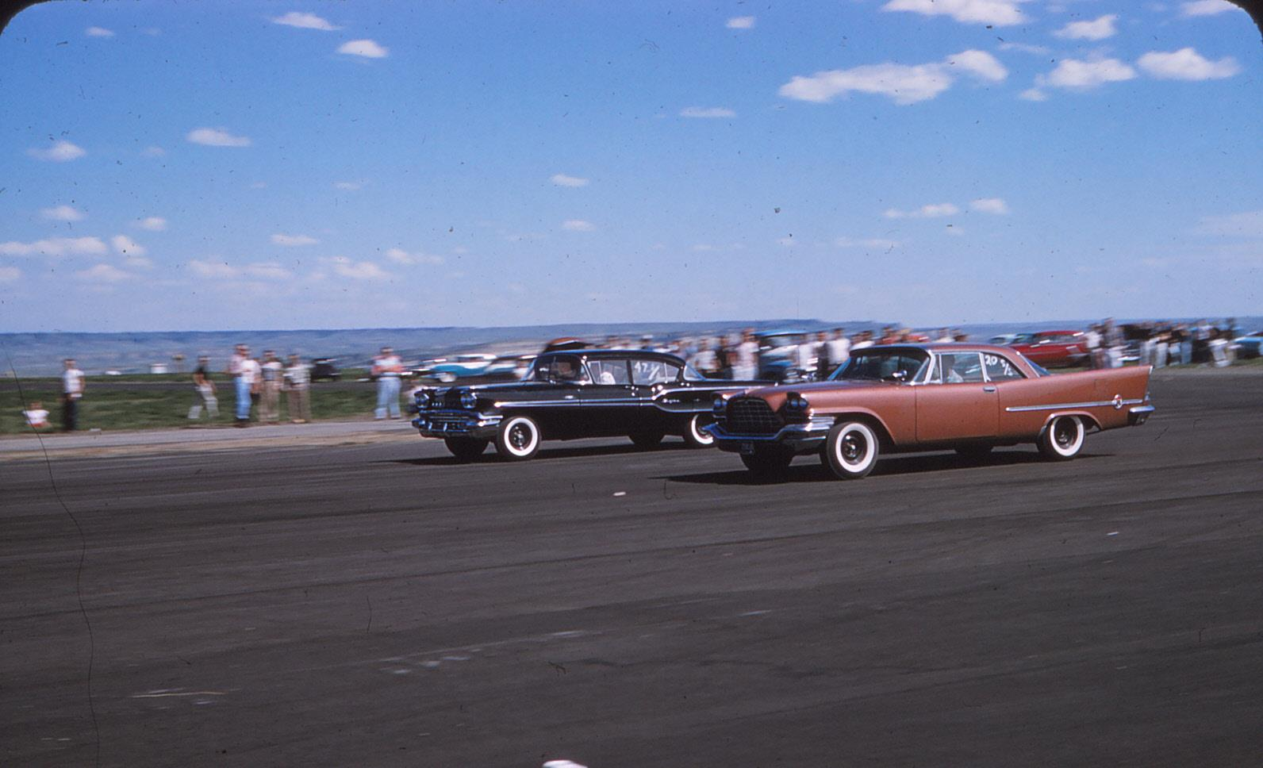

It came with a 120 MPH and Harold Wilcoxson installed a 150 MPH which was a 1958 300D. I put the original 120 MPH back in and was able to purchase a 150 MPH 300C from the Chrysler 300 Club in the 1960’s. I never installed the 150 MPH. Later I sold the 1958 300D 150 MPH to a person in Arizona.

The 300C now has about 196,000 miles. When John purchased the 300C, it had a noise in the engine, finally he pulled the heads and found a flat piston which he replaced. After moving to Portland in December 1964, later in March 1966, John had a valve stick open, so he pulled the engine and had a machine shop rebuild the engine with a new cam and solid lifters. Then in July 1966 he lost the wrist pipe keepers on two piston and pulled the engine again at his home and another rebuild, this time with 10 ½ pistons with engine balanced and over 400 HP.

The 300 still has the original Copper Brown Metallic paint. Finally, in the spring of 2019 we ordered new leather seat covers from Legendary Auto Interiors and carpets from Chester and Herod, Automotive Carpets Mfg. in Escondido, CA. as recommended by Rob Kern.

In July 21, 2019, we entered the 300C in the Forest Grove Concours d'Elegance - The Greater Portland, we were awarded a 2nd place in Class I – Chrysler Corporation 1949-1959.